Swaniti Global home page

[Swaniti Global](https://50a13c69-c795-4a83-b0f8-6f87fde24dcf-figmaiframepreview.figma.site/preview_page.html#/)

* Centers | [About Us](https://50a13c69-c795-4a83-b0f8-6f87fde24dcf-figmaiframepreview.figma.site/preview_page.html#/about)| [Impact](https://50a13c69-c795-4a83-b0f8-6f87fde24dcf-figmaiframepreview.figma.site/preview_page.html#/impact) | [Research and Insights](https://50a13c69-c795-4a83-b0f8-6f87fde24dcf-figmaiframepreview.figma.site/preview_page.html#/research) | [Events](https://50a13c69-c795-4a83-b0f8-6f87fde24dcf-figmaiframepreview.figma.site/preview_page.html#/events)

Hero section:   
Heading: Transforming Communities Through Evidence-Based Policy

Sub-heading: We empower governments and communities to create lasting change through rigorous research and innovative solutions.  
CTA: Our impact  
  
Numbers:

Funds Mobilised 165Mn+

Policies Reformed 35+

Global Countries 8+  
Active Projects: 23 Ongoing initiatives worldwide

Partners: 70+ Global collaborations  
  
About us  
At Swaniti, we have a deep understanding of how to leverage political economy to drive scalable and long-term change in energy transition. Working globally, we operate at the intersection of climate, governance and community to prompt action, unlock critical resources, and build agency amongst local stakeholders.   
CTA: About us page  
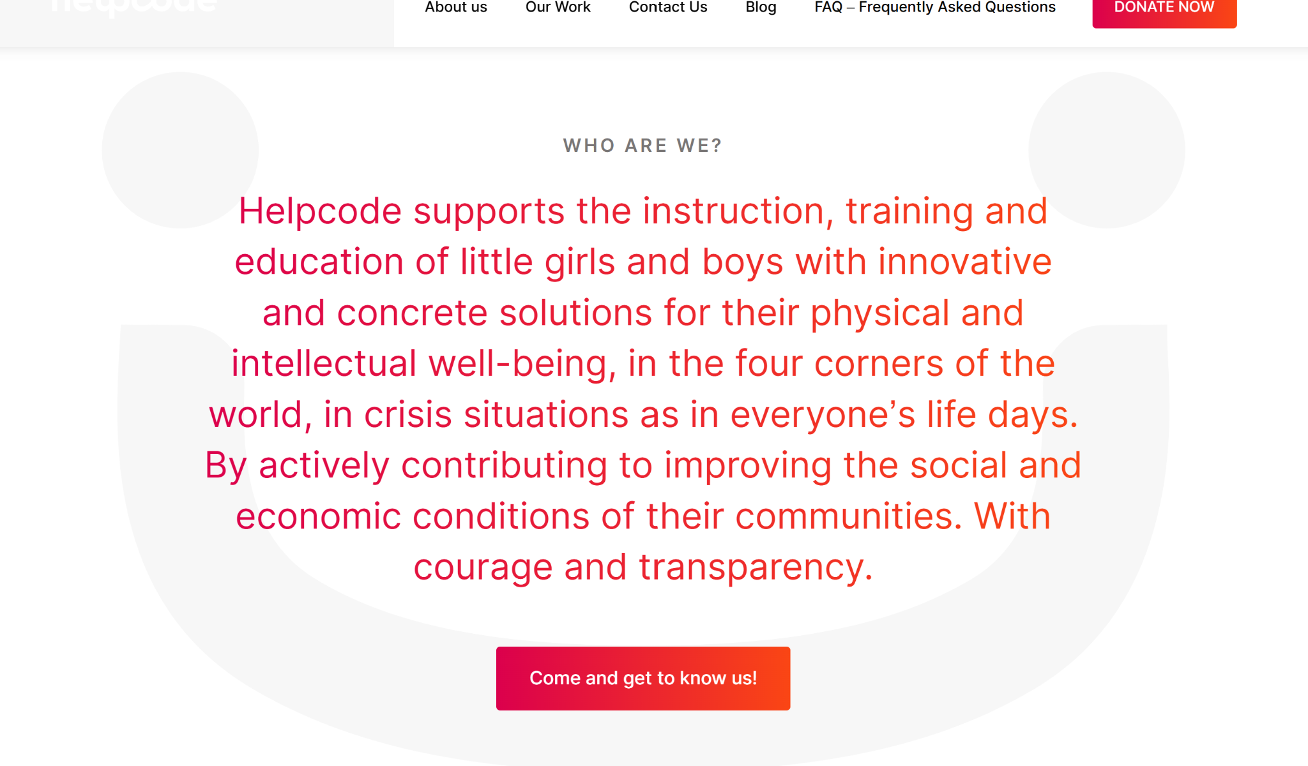

OUR APPROACH

Systemic reforms

Our work is rooted in improving the lives of the most vulnerable and disadvantaged through a systemic approach.

Unlocking willingness

Swaniti’s key area of focus is the political economy. Swaniti's core work consists in unlocking public funds by influencing stakeholders and activities in the political economy.

Strengthening Public Service Delivery

We work across the global south in economically disadvantaged geographies for the strongest impact.

## Our Global Operations

Map

Together, We Can Create Lasting Change

Partner with us to drive evidence-based policy and sustainable development

CTA: Partner with us:   
  
Footer  
Logo Swaniti Global

Independent research organization driving evidence-based policy and social change.

Twitter

LinkedIn

Facebook

YouTube

### Quick Links

* [Home](https://50a13c69-c795-4a83-b0f8-6f87fde24dcf-figmaiframepreview.figma.site/preview_page.html#/)
* [About Us](https://50a13c69-c795-4a83-b0f8-6f87fde24dcf-figmaiframepreview.figma.site/preview_page.html#/about)
* [Impact](https://50a13c69-c795-4a83-b0f8-6f87fde24dcf-figmaiframepreview.figma.site/preview_page.html#/impact)
* [Research and Insights](https://50a13c69-c795-4a83-b0f8-6f87fde24dcf-figmaiframepreview.figma.site/preview_page.html#/research)
* [Events](https://50a13c69-c795-4a83-b0f8-6f87fde24dcf-figmaiframepreview.figma.site/preview_page.html#/events)

### Centers

* [GCDI](https://50a13c69-c795-4a83-b0f8-6f87fde24dcf-figmaiframepreview.figma.site/preview_page.html#/center/gcdi)
* [CLEFS](https://50a13c69-c795-4a83-b0f8-6f87fde24dcf-figmaiframepreview.figma.site/preview_page.html#/center/clefs)
* [Sub National](https://50a13c69-c795-4a83-b0f8-6f87fde24dcf-figmaiframepreview.figma.site/preview_page.html#/center/subnational)
* [Green Livelihood](https://50a13c69-c795-4a83-b0f8-6f87fde24dcf-figmaiframepreview.figma.site/preview_page.html#/center/green-livelihood)

### Contact Us

* New Delhi, India
* info@swanitiglobal.org
* +91 9821959901,

© 2025 Swaniti Global. All rights reserved.

[Privacy PolicyTerms of Service](https://50a13c69-c795-4a83-b0f8-6f87fde24dcf-figmaiframepreview.figma.site/preview_page.html#)

Centres

* [GCDI](https://docs.google.com/document/d/1G6_lm0q3TMcLiPgQwS3ZQ4S0binco2IOE4zuT2lLTR4/edit?tab=t.cwr6km1j1hxt#heading=h.hq7pbet827s0)
* [CLESF](https://docs.google.com/document/d/1G6_lm0q3TMcLiPgQwS3ZQ4S0binco2IOE4zuT2lLTR4/edit?tab=t.pvbak6dmkfhc)
* [Centre for Sub-National Engagement](https://docs.google.com/document/d/1G6_lm0q3TMcLiPgQwS3ZQ4S0binco2IOE4zuT2lLTR4/edit?tab=t.5yq9jamxf8sj#heading=h.u4gmf7mnuutz)
* [Centre for Green Livelihoods](https://docs.google.com/document/d/1G6_lm0q3TMcLiPgQwS3ZQ4S0binco2IOE4zuT2lLTR4/edit?tab=t.bbuv0afam69i#heading=h.10vwx85r5haq)

[Photos](https://drive.google.com/drive/folders/10h6AQm1c8xmL_vmN5_FKBnzyU-z3Y9WN?usp=drive_link)

About Us

About Swaniti Global

Hero SectionHeading   
We are a global think tank dedicated to transforming policy into action, empowering governments and communities to create lasting change.

At Swaniti, we have a deep understanding of how to leverage political economy to drive scalable and long-term change in energy transition. Working globally, we operate at the intersection of climate, governance and community to prompt action, unlock critical resources, and build agency amongst local stakeholders.

OUR APPROACH

1. Systemic reforms

Our work is rooted in improving the lives of the most vulnerable and disadvantaged through a systemic approach.

1. Unlocking willingness

Swaniti’s key area of focus is the political economy. Swaniti's core work consists in unlocking public funds by influencing stakeholders and activities in the political economy.

1. Strengthening Public Service Delivery

We work across the global south in economically disadvantaged geographies for the strongest impact.

OUR MODEL

1. Value mapping

We embed team members within communities to align local aspirations with government resources, ensuring targeted and effective solutions.

1. Technical assistance:

We collaborate with communities and key government agencies to develop practical solutions for a sustainable energy transition.

1. Connecting the dots

We build consortiums consisting of experts, industries and civil society partners to drive coordinated and impactful action

1. Monitoring impact

We work closely with stakeholders to evaluate the scale and effectiveness of our initiatives, ensuring measurable progress on the ground.

Theory of Change

Building Systems for an Inclusive Energy Transition

At Swaniti, we believe that tackling climate change requires more than just bold targets… it demands systems that works for everyone, especially those most vulnerable to its impacts  
We understand that climate change is not a future possibility – it is a present crisis, and its consequences are not evenly distributed. Communities in the Global South, particularly those already living on the margins, are bearing the brunt of an accelerating climate emergency.  
From coal miners facing issues with just transition, to industries struggling to access green finances, and farmers experiencing low yields due to erratic weather, all of these are deepening existing vulnerabilities and testing the resilience of governance systems.

While national and international commitments to clean energy and net-zero goals are growing, implementation often falters on the ground because:

* Limited technical capacity at the sub-national level
* A lack of locally contextualised transition frameworks
* Insufficient tools to monitor, evaluate, and deliver impact

This is where Swaniti begins its work. We start by engaging with those who are most affected – local leaders, frontline workers, and community members. Their insights are not supplementary; they are central. Our first steps involve:

* Listening to community experiences and aspirations
* Mapping local assets and capacities
* Identifying underutilized public resources that can enable a inclusive transition

These insights inform a deeper understanding of what climate equity should look like on the ground.

We bring out solutions from within communities—By building a collaborative ecosystem that unlocks public funds and resources and combines it with local partners and community leaders we build out sustainable solutions.

Then comes the implementation. Our technical teams work closely with sub-national governments. We are embedded within departments to support real-time planning, problem-solving and implementation. From enabling solar deployment and improving climate finance access, to integrating resilience planning and building local data systems. we help convert intent into impact.

For us, climate action is not just about reducing emissions; it’s about building institutional capacity (unlocking public funds and resources), empowering communities (bringing change through increased representation), and enabling transformation (enabling action from key stakeholders) that reaches the last mile.

Our Journey

Sub heading: From a small team with a big vision to a global network driving change

2010

Foundation

Swaniti Global was established with a vision to bridge the gap between research and policy implementation.

2013

National Expansion

Expanded operations to 10 states across India, working directly with state governments.

2016

International Recognition

Received global recognition for innovative governance models and began international partnerships.

2020

Centers of Excellence

Launched specialized research centers: GCDI, CLEFS, Sub National, and Green Livelihood.

2025

Global Impact

Now operating in 25+ countries, impacting over 2 million lives through evidence-based policy research.

New partner logos

[partner logos](https://drive.google.com/drive/folders/1fTv44z760J1hJsB8w7JD-6-S52daOVQl?usp=drive_link)

## **Academic Institutions**







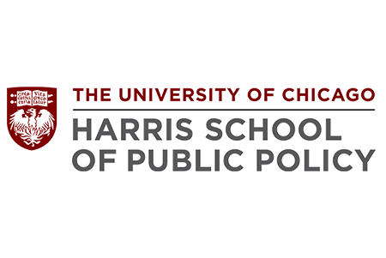

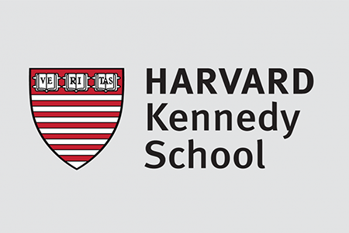

































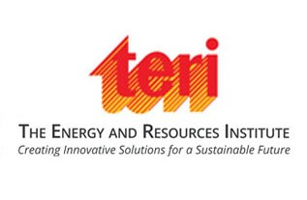







## **Organizations**



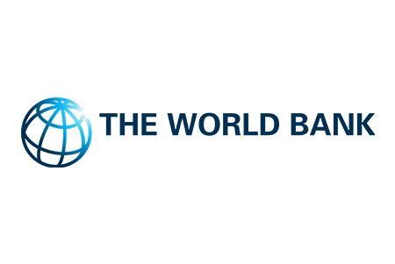



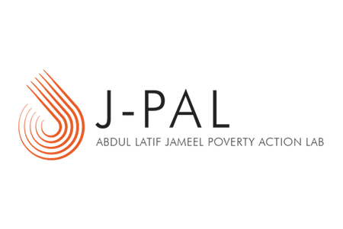





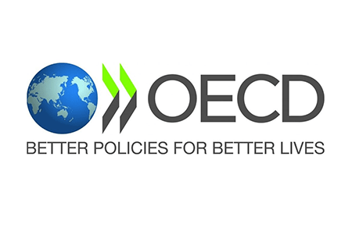



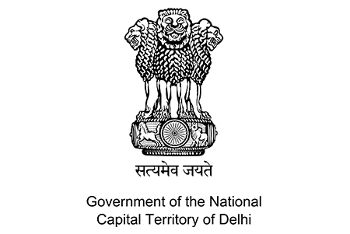

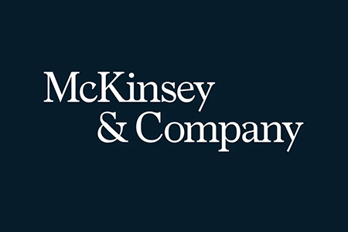





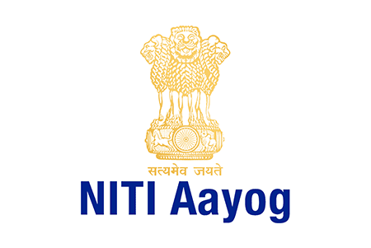

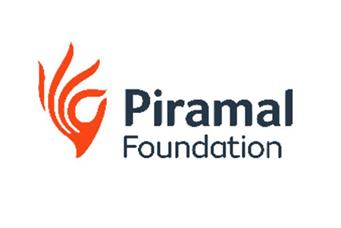



Impact

Numbers:

Funds Mobilised 165Mn+

Policies Reformed 35+

Global Countries 8+  
Active Projects: 23 Ongoing initiatives worldwide

Partners: 70+ Global collaborations  
  
  
Ensuring public services are delivered to the beneficiary at the last mile.  
  
Program impact  
  
Community Empowerment

Swaniti’s bottom-up approach has ensured that the voices of local communities are heard, fostering a sense of ownership and responsibility towards sustainable practices.

### Inclusivity and Equity

Targeting marginalized groups, including SCs, STs, and women, Swaniti has promoted inclusive development, ensuring that the benefits of these interventions reach the most vulnerable sections of society.

### Capacity Building

Training programs and capacity-building sessions have equipped local communities with the skills and knowledge needed to sustain and scale these interventions, promoting long-term resilience and self-reliance.

### Policy Recommendations

By conducting rigorous field research and engaging with government stakeholders, Swaniti has provided valuable policy recommendations that have led to improved implementation of various government schemes.

### Collaborative Frameworks

Swaniti has successfully built networks between state governments, policy leaders, private sector stakeholders, and communities, creating a collaborative framework for effective governance and developmental growth.

Impact stories.

Research and publication

https://docs.google.com/spreadsheets/d/1JnyAyEE1UGVI8p_yaCm4nTkjGlo3X5dkVeKLIxO0hq4/edit?usp=sharing